Golden Isles Woodworkers and Woodturners
March 2017 www.GIWW.org

Meeting Notes |  | President's Message
UPCOMING EVENTS

GAW Symposium “Turning Southern Style” - Registration is now open
The annual GAW symposium is scheduled for September 15 – 17 in Dalton, GA

Beads of Courage Project
Download information and specifications from our Club Projects web page:

ttp://www.giww.org/club-projects.html

Next Meeting

Bring A Chair!

Member's Work

Barbara
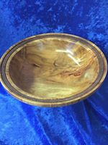 | 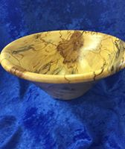
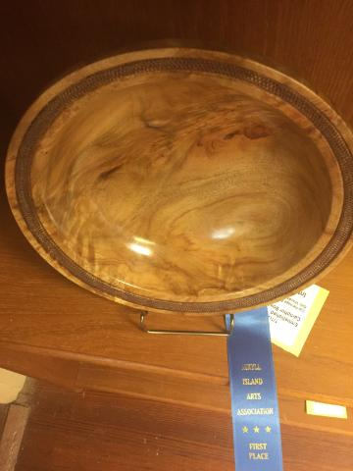 | 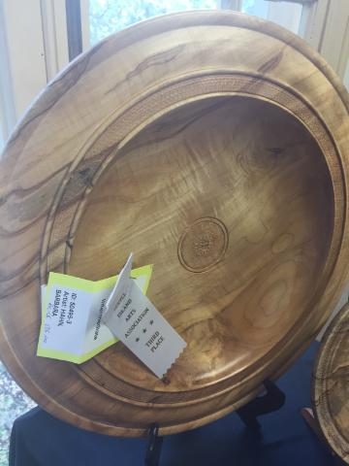
1st Place  Jekyll Arts Association | 3rd Place  Jekyll Arts Association
Member's Work

Herb

... your work is missing! Send Pics!

Next Meeting

Bring A Chair!

